Executive Summary

The tagging feature allows all Haibrid users to efficiently categorize and retrieve saved sources by adding and managing tags, enhancing organization and searchability. This supports personalized and collaborative information management, reducing reliance on rigid folder structures. It aims to improve productivity by enabling quick and contextual access to saved online resources.

Target Release
Epic | https://braice.atlassian.net/browse/HAIB-864
Figma | Extension:  https://www.figma.com/design/n2FYTev0A6bT7CCK3626BR/Haibrid-DS-v1.2?node-id=928-21729&t=Ep9O0ytgSCNB5NBo-4  Snackbar:  https://www.figma.com/design/n2FYTev0A6bT7CCK3626BR/Haibrid-DS-v1.2?node-id=928-21929&t=Ep9Oa0ytgSCNB5NBo-4
Document Status | [UPDATED]
Owner | YELENA MURADYAN

Objective

Tagging will help users retrieve context of sources and information contained within them, leading to better use of knowledge and information found online, easier context recall and source grouping, and increased productivity as a result, making Haibrid more useful tool.

Assumptions
- Users may want to add tags while browsing (using the extension)
- They may want to add existing tags to sources with little friction
- Users will have high volume of sources that need to be organized
- Varied use cases (research, personal, collaborative work) so different needs for tags
- Users require quick and contextual retrieval of sources
- Users might want to search or filter sources/projects based on the tags
- Users might be using specific tags more often, so we will be suggesting the 3 most recently used tags
- Users might need to use several tags for the same source
- Most users will add tags using the extension with little re-organizing in the dashboard

Requirements
- Extension components order redesign top to bottom
- “Save to”
- “Saved to”
- “Tags”
- “Note”
- Interacting with Tags from the extension
- “+Add Tag” button
  - has two states
    - passive (neutral state) 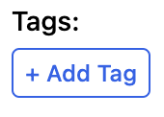
    - active (on hover or click)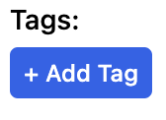

- Click on the “+Add Tags” opens a placeholder with a search function
  - Inside the placeholder body text “Search or Create tag”.
  - If the project to which the source is to be added already has tags, they appear below search as a suggestion by recency of use. 3,5 of them are visible, the rest goes under scroll. Users can also navigate with keyboards up/down arrows. Hitting enter or by clicking on the suggested tags. will add the selected tag to the source.
  - If there are no available tags, its has a copy of “No tags found”
  - To create a new tag user should type out the new tag, and add it by either clicking on the “Enter” or click on the Create button below. (see visual)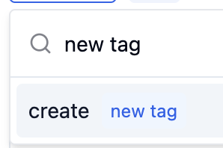
  - the new tag should be typed out next to the “Create” as it is being typed in the input.
  - a [Space] should not be considered as a character in the tag. Meaning, if a user has typed out a tag name + [space] and hit “enter’ a tag should be created without the[space].
  - When the user starts typing, all matching tags used across the projects should appear in the dropdown instead of the recent ones, and if there are a lot of tags matching the typed letters, the list of the tags should be displayed with the same logic we have for the projects dropdown (3.5 items + scroll, so that the user understands there is more)
  - If the user types in an already existing tag text and hits enter, the existing tag should be auto-selected and placed, and the newly typed letters should disappear (indicating that the tag has already been added).
  - In any case, if a user creates a new tag, types in an existing one, or starts searching and selects a tag from the suggestions, letters should disappear from the input.
- New tags add from left to right, after the most recently added tag.
- Newly added tags should have an “x”- remove button in their bounding box, which should “Remove” a tag, in case it’s triggered.
  - When the user clicks on “X” for any of the added tags, this tag should be shown on top of the Recents list when the user opens the list next time.
- If the source already has tags, they should be visualized next to the “+Add Tags” button.
- Each tag length limitation - 30 characters
- Users should be able to add/create unlimited number of tags per source/highlight
- The tags list should never exceed 2 rows, if there are more tags selected that wouldn’t fit into 2 rows, a scroll should appear within the input.
- When the user selects one of the most recent tags, and then clicks on the input again, selected tag should be replaced by another (4th) most recently used tag
- If the user starts typing, then clicks somewhere else within the extension, the dropdown should close and the input field should become empty.

User interaction and design

All changes should be applied to both extension and snackbar

- Order of input fields in the extension/snackbar needs to be changed to the following:
- “Save to” on the top
- “Tags” in the middle
- “Note” in the bottom
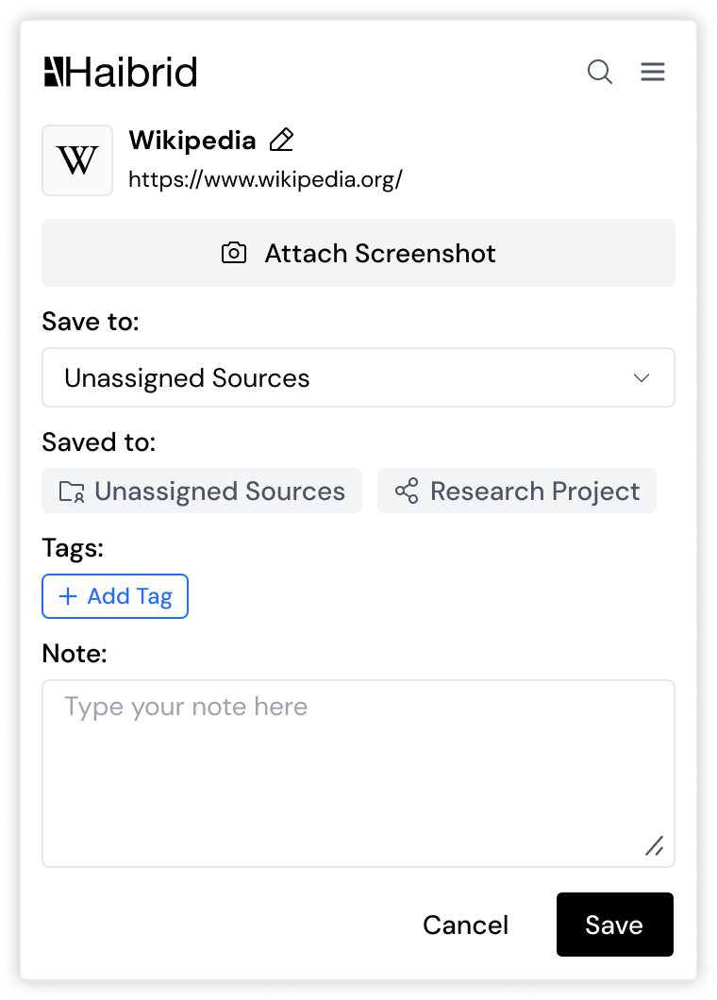
- When the user clicks on the 'Add Tags'' input inside of the extension window/snackbar, recently used tags should be displayed with the most recently used tag on the top. Each tag should be on a separate row regardless of its length.
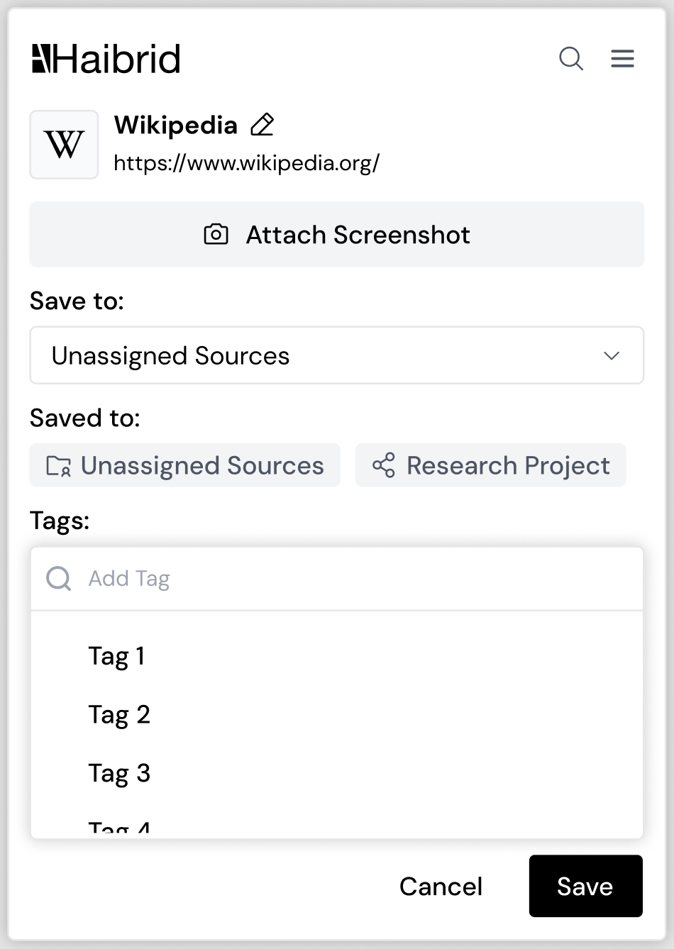

3) “+Add Tag” button
  - has two states
    - passive (neutral state) 
    - active (on hover or click)
Open Questions

Next phase should consider

- First time experience for adding tags

